

**Open Ended Lab**

**Course Code: CSE 3120**

**Course Title: Web Programming Lab**

**Section: 1**

**Submitted To**

**Nasir Uddin Ahmed**

**University of Liberal Arts Bangladesh**

**Submitted By**

**Rifat sarkar(212014001)**

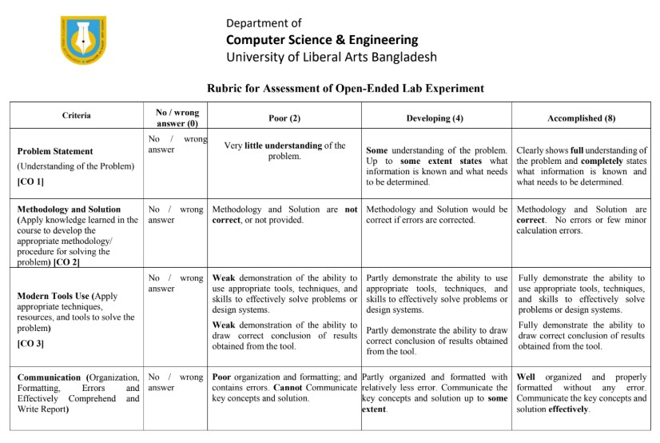

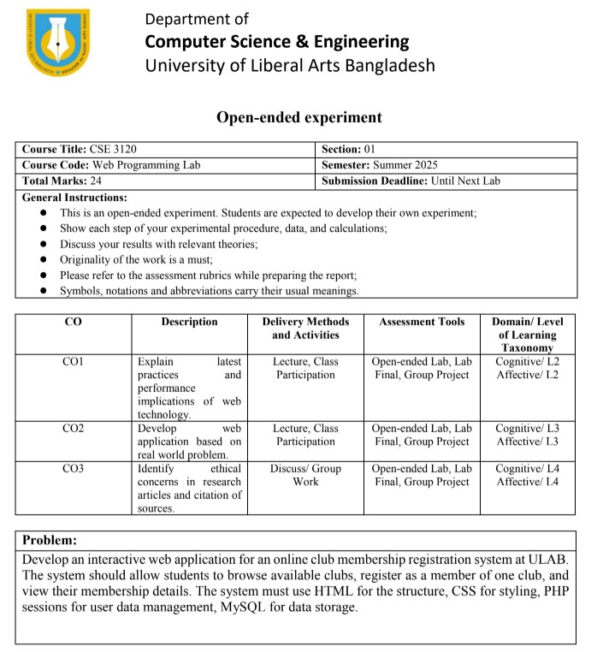

**Introduction**

The regular classes instructions, additional activities are important for creating the development of students in today's educational environment. Students can join several clubs in the University of Liberal Arts Bangladesh (Ulab), including debate club, Photography Club,

Programming Club and Sports Club. Clubs join clubs often include offline registration processes, including paper forms and manual permits, leading to lack of disabilities, repetition of efforts and openness. The project aims to develop and distribute an online club membership registration system that simplifies the club's surfing, membership registration and secure membership administration. Students can join several clubs in the University of Liberal Arts Bangladesh (Ulab), including debate club, Photography Club, Programming Club and Sports Club. Clubs join clubs often include offline registration processes, including paper forms and manual permits, leading to lack of disabilities, repetition of efforts and openness. The project aims to develop and distribute an online club membership registration system that simplifies the club's surfing, membership registration and secure membership for membership to solve these problems.The main objective of this system is to show how to integrate modern web technologies including HTML, CSS, JavaScript, PHP session and MySQL to provide a practical application. The project emphasizes how important it is to include scalability, safety and purpose in software design. While verification of the server side guarantees computer compression

**Implementation**

There were many well -organized stages to introduce the club membership system. To provide user -friendly interfaces, the front end was first created using HTML and CSS. While Register.php included a registration form, the Lister Index.php home each club that was available with details. CSSS was used to create a responsible, similar and clean design. JavaScript was used to increase the tool for verification of the client side. Before allowing form submission, the format of the Student -ID, the length of the name and validity of the E -post was examined.

The user was required to handle the user session and process requests on the PHP back. To prevent repeated database questions and preserve the login state on the pages, the user information in the session variable on a successful registration was stored. Requirements for the site were among security measures to prevent SQL injections and CSRF symbols to prevent counterfeiting.

MySQL was used for database architecture because its addiction and PHP interoperability. The club information was held in a club table, while the student data was placed in the membership table. A student can only become a member of a club, which was used by labeling the student_id column as unique. Strong data integrity was secured by this prohibition at database level. Eventually, surfing, registration and dashboards were made possible by innocent integration of all parts of the workflakes.

**Website screenshot:**

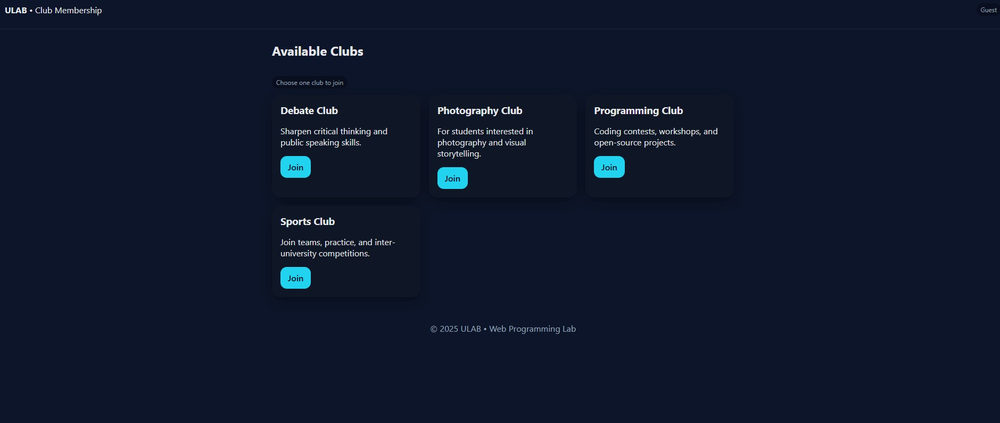

**Homepage**

**SQL Database SS:**



**Club Database**

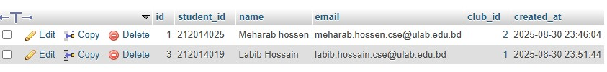

**Member List**

# Code

## Config.php

<?php

// config.php - DB connection + session bootstrap mysqli_report(MYSQLI_REPORT_ERROR | MYSQLI_REPORT_STRICT);

$host = "localhost";

$user = "root";

$pass = "";

$dbname = "ulab_club";

try {

$conn = new mysqli($host, $user, $pass, $dbname);

$conn->set_charset("utf8mb4");

} catch (Exception $e) { http_response_code(500); exit("Database connection failed.");

}

if (session_status() !== PHP_SESSION_ACTIVE) { session_start();

}

// Simple CSRF helper if (empty($_SESSION['csrf_token'])) {

$_SESSION['csrf_token'] = bin2hex(random_bytes(32));

}

function csrf_field() {

$t = htmlspecialchars($_SESSION['csrf_token'] ?? '', ENT_QUOTES, 'UTF-8'); echo '<input type="hidden" name="csrf_token" value="'.$t.'">';

}

function verify_csrf() { if (!isset($_POST['csrf_token']) || !hash_equals($_SESSION['csrf_token'], $_POST['csrf_token'])) { http_response_code(400); exit("Invalid CSRF token.");

}

}

?>

## dashboard

<?php include 'config.php'; if (!isset($_SESSION['student_id'])) { header("Location: index.php"); exit; }

$sid = $_SESSION['student_id'];

$stmt = $conn->prepare("

SELECT m.name, m.email, m.student_id, c.name AS club_name

FROM members m

JOIN clubs c ON c.id = m.club_id WHERE m.student_id=?

");

$stmt->bind_param("s", $sid);

$stmt->execute();

$profile = $stmt->get_result()->fetch_assoc(); if (!$profile) { session_destroy(); header("Location: index.php"); exit; }

?>

<!doctype html>

<html lang="en">

<head>

<meta charset="utf-8">

<meta name="viewport" content="width=device-width, initial-scale=1"> <title>Dashboard</title>

<link rel="stylesheet" href="style.css">

</head>

<body>

<header>

<div>Dashboard</div>

<nav>

<a href="index.php">Clubs</a>

<a style="margin-left:8px" href="logout.php">Logout</a>

</nav>

</header>

<div class="container">

<?php if (!empty($_SESSION['flash'])): ?>

<div class="card" style="border-left:4px solid var(--accent)">

<?= htmlspecialchars($_SESSION['flash']); unset($_SESSION['flash']); ?>

</div>

<?php endif; ?>

<div class="card">

<h3>Membership Details</h3>

<p><strong>Name:</strong> <?= htmlspecialchars($profile['name']); ?></p>

<p><strong>Student ID:</strong> <?= htmlspecialchars($profile['student_id']); ?></p>

<p><strong>Email:</strong> <?= htmlspecialchars($profile['email']); ?></p>

<p><strong>Club:</strong> <?= htmlspecialchars($profile['club_name']); ?></p> </div>

</div>

<footer>© <?= date('Y'); ?> ULAB • Web Programming Lab</footer> </body>

</html>

## index

<?php include 'config.php'; ?>

<!doctype html>

<html lang="en">

<head>

<meta charset="utf-8">

<meta name="viewport" content="width=device-width, initial-scale=1">

<title>ULAB Club Membership</title>

<link rel="stylesheet" href="style.css">

</head>

<body>

<header>

<div><strong>ULAB</strong> • Club Membership</div> <nav>

<?php if(isset($_SESSION['student_id'])): ?>

<a class="btn" href="dashboard.php">Dashboard</a>

<a style="margin-left:8px" href="logout.php">Logout</a>

<?php else: ?>

<span class="chip">Guest</span>

<?php endif; ?>

</nav>

</header>

<div class="container">

<h2>Available Clubs</h2>

<p class="chip">Choose one club to join</p>

<div class="grid">

<?php

$stmt = $conn->prepare("SELECT id, name, description FROM clubs ORDER BY name"); $stmt->execute(); $res = $stmt->get_result(); while($row = $res->fetch_assoc()):

?>

<div class="card">

<h3><?= htmlspecialchars($row['name']); ?></h3>

<p><?= htmlspecialchars($row['description']); ?></p>

<a class="btn" href="register.php?club_id=<?= (int)$row['id']; ?>">Join</a>

</div>

<?php endwhile; ?>

</div>

</div>

<footer>© <?= date('Y'); ?> ULAB • Web Programming Lab</footer>

</body>

</html>

## Log out

<?php session_start(); $_SESSION = []; if (ini_get('session.use_cookies')) { $params = session_get_cookie_params(); setcookie(session_name(), '', time() - 42000, $params['path'], $params['domain'],

$params['secure'], $params['httponly']

);

}

session_destroy(); header("Location: index.php"); exit; ?>

### register

<?php

include 'config.php';

$club_id = isset($_GET['club_id']) ? (int)$_GET['club_id'] : 0;

$club = null; if ($club_id > 0) {

$stmt = $conn->prepare("SELECT id, name FROM clubs WHERE id=?");

$stmt->bind_param("i", $club_id);

$stmt->execute();

$club = $stmt->get_result()->fetch_assoc(); if (!$club) { http_response_code(404); exit("Club not found."); }

} else { http_response_code(400); exit("Missing club id.");

}

?>

<!doctype html>

<html lang="en">

<head>

<meta charset="utf-8">

<meta name="viewport" content="width=device-width, initial-scale=1">

<title>Register • <?= htmlspecialchars($club['name']); ?></title>

<link rel="stylesheet" href="style.css">

<script defer src="script.js"></script>

</head>

<body>

<header>

<div><a href="index.php">← Back</a></div>

<nav></nav>

</header>

<div class="container">

<h2>Register for <?= htmlspecialchars($club['name']); ?></h2>

<form action="save_registration.php" method="POST" onsubmit="return validateForm()">

<?php csrf_field(); ?>

<input type="hidden" name="club_id" value="<?= (int)$club['id']; ?>">

<label for="student_id">Student ID</label>

<input type="text" id="student_id" name="student_id" placeholder="e.g., 231014034 or

ULAB-23-1034" required>

<div id="sid_msg" class="msg"></div>

<label for="name">Full Name</label>

<input type="text" id="name" name="name" placeholder="Your full name" required> <div id="name_msg" class="msg"></div>

<label for="email">Email</label>

<input type="email" id="email" name="email" placeholder="you@ulab.edu.bd" required> <div id="email_msg" class="msg"></div>

<div style="margin-top:14px">

<button class="btn" type="submit">Register</button>

<a style="margin-left:8px" href="index.php">Cancel</a>

</div>

</form>

</div>

</body>

</html>

### save_registration

<?php include 'config.php'; verify_csrf();

// Basic server-side validation

$student_id = trim($_POST['student_id'] ?? '');

$name = trim($_POST['name'] ?? ''); $email = trim($_POST['email'] ?? '');

$club_id = (int)($_POST['club_id'] ?? 0);

if (!preg_match('/^[A-Za-z0-9\-]{6,20}$/', $student_id)) { exit("Invalid student ID.");

}

if (!preg_match('/^[A-Za-z][A-Za-z\s\'.\-]{2,60}$/', $name)) { exit("Invalid name.");

}

if (!filter_var($email, FILTER_VALIDATE_EMAIL)) { exit("Invalid email.");

}

// Ensure club exists

$chk = $conn->prepare("SELECT id FROM clubs WHERE id=?");

$chk->bind_param("i", $club_id);

$chk->execute(); if (!$chk->get_result()->fetch_row()) { exit("Invalid club.");

}

// Insert or handle duplicate (one club per student) try {

$stmt = $conn->prepare("INSERT INTO members (student_id, name, email, club_id) VALUES (?, ?,

?, ?)");

$stmt->bind_param("sssi", $student_id, $name, $email, $club_id); $stmt->execute();

} catch (mysqli_sql_exception $e) {

// Duplicate student_id -> fetch and set session then redirect if ($e->getCode() === 1062) {

$fetch = $conn->prepare("SELECT m.name, m.email, m.club_id FROM members m WHERE m.student_id=?");

$fetch->bind_param("s", $student_id);

$fetch->execute();

$existing = $fetch->get_result()->fetch_assoc();

$_SESSION['student_id'] = $student_id;

$_SESSION['name'] = $existing['name'];

$_SESSION['club_id'] = (int)$existing['club_id'];

$_SESSION['flash'] = "You are already a member. Showing your dashboard."; header("Location: dashboard.php"); exit; } else {

http_response_code(500); exit("Unable to save registration.");

}

}

// Success -> set session and redirect

$_SESSION['student_id'] = $student_id;

$_SESSION['name'] = $name;

$_SESSION['club_id'] = $club_id;

$_SESSION['flash'] = "Registration successful!"; header("Location: dashboard.php"); exit; ?>

### SQL

-- ULAB Club Membership System - Database Script

-- Create database and tables

CREATE DATABASE IF NOT EXISTS ulab_club CHARACTER SET utf8mb4 COLLATE utf8mb4_general_ci;

USE ulab_club;

-- Clubs table

CREATE TABLE IF NOT EXISTS clubs ( id INT AUTO_INCREMENT PRIMARY KEY, name VARCHAR(100) NOT NULL,

description TEXT

) ENGINE=InnoDB;

-- Members table (one club per student enforced by UNIQUE KEY) CREATE TABLE IF NOT EXISTS members ( id INT AUTO_INCREMENT PRIMARY KEY, student_id VARCHAR(32) NOT NULL, name VARCHAR(100) NOT NULL, email VARCHAR(120) NOT NULL, club_id INT NOT NULL,

created_at TIMESTAMP DEFAULT CURRENT_TIMESTAMP,

UNIQUE KEY uniq_student (student_id),

CONSTRAINT fk_members_club FOREIGN KEY (club_id) REFERENCES clubs(id) ON DELETE

RESTRICT ON UPDATE CASCADE

) ENGINE=InnoDB;

-- Seed some clubs

INSERT INTO clubs (name, description) VALUES

('Photography Club', 'For students interested in photography and visual storytelling.'),

('Debate Club', 'Sharpen critical thinking and public speaking skills.'),

('Sports Club', 'Join teams, practice, and inter-university competitions.'),

('Programming Club', 'Coding contests, workshops, and open-source projects.')

ON DUPLICATE KEY UPDATE description = VALUES(description);

**css**

:root { --bg:#0f172a; --card:#111827; --text:#e5e7eb; --muted:#94a3b8; --accent:#22d3ee;

--danger:#ef4444; --ok:#22c55e;} * { box-sizing: border-box; } body { margin:0; font-family: system-ui, -apple-system, Segoe UI, Roboto, sans-serif; background:

var(--bg); color: var(--text); } header { padding: 24px; display:flex; justify-content:space-between; align-items:center; border-bottom:1px solid #1f2937; }

a { color: var(--accent); text-decoration: none; }

.container { max-width: 900px; margin: 24px auto; padding: 0 16px; }

.grid { display:grid; gap:16px; grid-template-columns: repeat(auto-fill, minmax(260px,1fr)); } .card { background: var(--card); padding: 16px; border-radius: 16px; box-shadow: 0 8px 24px rgba(0,0,0,0.35); }

.card h3 { margin: 0 0 8px; }

.btn { display:inline-block; padding:10px 14px; border-radius:12px; background: var(--accent); color:#0b1020; font-weight:600; border:0; cursor:pointer; }

.btn:disabled { opacity: .6; cursor:not-allowed; }

form { background: var(--card); padding: 20px; border-radius: 16px; } label { display:block; margin: 10px 0 6px; color: var(--muted); } input, select { width:100%; padding:10px; border-radius:10px; border:1px solid #334155; background:#0b1020; color:var(--text); }

.msg { font-size: 13px; margin-top: 4px; }

.msg.ok { color: var(--ok); }

.msg.err { color: var(--danger); }

.chip { display:inline-block; padding:4px 8px; border-radius:999px; background:#0b1020; color:var(--muted); font-size:12px; } footer { text-align:center; color:var(--muted); padding: 24px; }

**Database schema.**

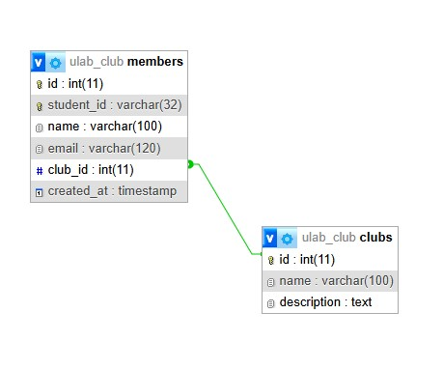

#### Results

Positive and confirmed results were achieved from the final implementation of the club's membership registration system. With only one click, students can now register easily and see all groups that were introduced on the website. Using JavaScript, the registration form that uses the user entrance in real time helps users to correct the errors before presenting. This significantly reduced illegal entries. PHP's verification of the servers side ensured that only secure and accurate data made them in the database after presenting it.

A student's name, e -post address, club preference and student -ID were registered in the members' table on successful registration. PHP sessions stored significant information at the same time, so that the student can be led to their own dashboard. The name and registration of the club was one of the confirmation membership details that were prominent on this dashboard.

The system's ability to prevent duplicate registration was a significant performance. The unique barrier in the database allowed the system to identify the duplicate when a student tried to re -register using the same ID. Instead of creating a new entry, the system anchored the student for its current member information. Data integrity was preserved by this enforcement.

All things were considered, the system meets its goals: a functional online registration process, secure increased management, accurate database storage and manual offline techniques improved user experience.

**Discussion:**

This experiment demonstrates many important aspects of the development of web applications. First, it shows that integration of backnd security and verification above provides strong defense against errors or infiltration in addition to the user's simple. While the Backnd check stopped malicious data insert, Live Verification Alert promoted accurate entrance. One of the best practices in modern software technique is double layer method.

Efficiency and safety increased sharply when using PHP sessions. The sessions kept the need to enter the data or provide information on unprotected query strings to users, the sessions kept the subscription facts on the server side safe. Flash messages, secure dashboard access and persistent logins were made possible by it. Similarly, the unauthorized CSRF token method, which reflects the actual safety requirements in industry safety, reflects the presentations.

MySQL did a good job for organized data storage on behalf of the database, which implements sanctions as the student's unique membership. MySQL provided addiction, acid compliance and simple php interaction in this educational environment, despite the fact that relationship databases can sometimes limit the scalability of large systems.

Concerns about morality were also taken into account. All codes were made of scratches, and no external library was used without permission. In open experiments it guarantees specificity, increases intellectual property and shows academic integrity.

**Conclusion**

To make our open laboratory experiment effectively created a functioning online system for the Ulab Club membership registration. Students can easily check their membership details, browse different groups and register safely by using the system. Through the integration of HTML, CSS, JavaScript, PHP and MySQL, the project shows how different web technologies work together to address practical problems.

The project achieved its goals by setting important functions such as verification of the client side and servers side, session management, CSRF protection and database integrity through obstacles in behavior. "A student, a club" rule was successfully implemented by the system, and preserved the correct member data. The results show practical applications of web programming concepts and show increased efficiency compared to traditional offline processes.

This experiment emphasized the importance of creating a balance between safety and purpose from a learning point of view. By guaranteeing the originality of work and terminating literary theft, it also addressed moral difficulties. Future promotion may include integration of e -mail and SMS information for students, so that safe membership transfers in clubs or introduce an administrator panel for club rankers.

All things were assessed, this open laboratory effectively meets technical integration, creative problem solving and illuminating moral software development methods, and meets the desired course goals (CO1-CO3).